What is Cloud Federation?

S
shubhikagarg1999

• Read
• Discuss
• Courses

Cloud Federation, also known as Federated Cloud is the deployment and management of several external and internal cloud computing services to match business needs. It is a multi-national cloud system that integrates private, community, and public clouds into scalable computing platforms. Federated cloud is created by connecting the cloud environment of different cloud providers using a common standard.
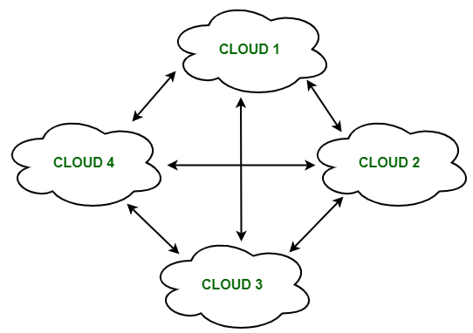
Federated Cloud

The architecture of Federated Cloud:
The architecture of Federated Cloud consists of three basic components:
1. Cloud Exchange
The Cloud Exchange acts as a mediator between cloud coordinator and cloud broker. The demands of the cloud broker are mapped by the cloud exchange to the available services provided by the cloud coordinator. The cloud exchange has a track record of what is the present cost, demand patterns, and available cloud providers, and this information is periodically reformed by the cloud coordinator.
2. Cloud Coordinator
The cloud coordinator assigns the resources of the cloud to the remote users based on the quality of service they demand and the credits they have in the cloud bank. The cloud enterprises and their membership are managed by the cloud controller.
3. Cloud Broker
The cloud broker interacts with the cloud coordinator, analyzes the Service-level agreement and the resources offered by several cloud providers in cloud exchange. Cloud broker finalizes the most suitable deal for their client.
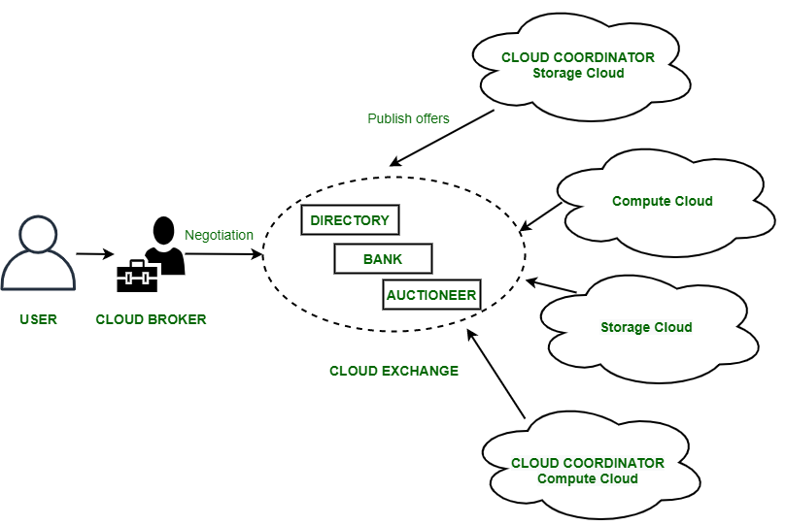
Federal Cloud Architecture

Properties of Federated Cloud:
- In the federated cloud, the users can interact with the architecture either centrally or in a decentralized manner. In centralized interaction, the user interacts with a broker to mediate between them and the organization. Decentralized interaction permits the user to interact directly with the clouds in the federation.
- Federated cloud can be practiced with various niches like commercial and non-commercial.
- The visibility of a federated cloud assists the user to interpret the organization of several clouds in the federated environment.
- Federated cloud can be monitored in two ways. MaaS (Monitoring as a Service) provides information that aids in tracking contracted services to the user. Global monitoring aids in maintaining the federated cloud.
- The providers who participate in the federation publish their offers to a central entity. The user interacts with this central entity to verify the prices and propose an offer.
- The marketing objects like infrastructure, software, and platform have to pass through federation when consumed in the federated cloud.

Benefits of Federated Cloud:
- It minimizes the consumption of energy.
- It increases reliability.
- It minimizes the time and cost of providers due to dynamic scalability.
- It connects various cloud service providers globally. The providers may buy and sell services on demand.
- It provides easy scaling up of resources.

Challenges in Federated Cloud:
- In cloud federation, it is common to have more than one provider for processing the incoming demands. In such cases, there must be a scheme needed to distribute the incoming demands equally among the cloud service providers.
- The increasing requests in cloud federation have resulted in more heterogeneous infrastructure, making interoperability an area of concern. It becomes a challenge for cloud users to select relevant cloud service providers and therefore, it ties them to a particular cloud service provider.
- A federated cloud means constructing a seamless cloud environment that can interact with people, different devices, several application interfaces, and other entities.

Federated Cloud technologies:
The technologies that aid the cloud federation and cloud services are:
1. OpenNebula
It is a cloud computing platform for managing heterogeneous distributed data center infrastructures. It can use the resources of its interoperability, leveraging existing information technology assets, protecting the deals, and adding the application programming interface (API).
2. Aneka coordinator
The Aneka coordinator is a proposition of the Aneka services and Aneka peer components (network architectures) which give the cloud ability and performance to interact with other cloud services.
3. Eucalyptus
Eucalyptus defines the pooling computational, storage, and network resources that can be measured scaled up or down as application workloads change in the utilization of the software. It is an open-source framework that performs the storage, network, and many other computational resources to access the cloud environment.

L What is an SLA?
A service-level agreement (SLA) is a commitment between a service provider and a client. Particular aspects of the service, such as quality, availability, responsibilities are agreed upon between the service provider and the service user. It defines:
- The metrics used to measure the level of service provided.
- Remedies or penalties resulting from failure to meet the promised service level expectations.
The most common component of an SLA is that the services should be provided to the customer as agreed upon in the contract. It is a critical component of any technology vendor contract. For example, Internet service providers will commonly include service level agreements within the terms of their contracts with customers to define the level of service being sold in plain language terms. Usually, SLAs are between companies and external suppliers, but they may also be between two departments within a company.
In this case, the SLA will typically have a technical definition in mean time between failures (MTBF), mean time to repair or mean time to recovery (MTTR), identifying which party is responsible for reporting faults or paying fees, responsibility for various data rates, throughput, jitter, or similar measurable details. The Service Level Agreement includes:
- Detailed service overview
- Speed of service delivery
- Plan for performance monitoring
- Description of the reporting procedure
- List of penalties that will be applied in case of agreement violations
- Constraints

Types of SLA
The selection of the types of SLA in an organization depends on many significant aspects.
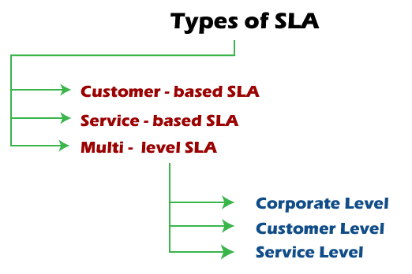
While some are targeted at individual customer groups, others discuss issues relevant to entire companies. This is because the needs of one user differ from another. Here are some types of SLAs used by businesses today and how each one is utilized for specific situations:
1. Customer-based SLA
This type of agreement is used for individual customers and comprises all relevant services that a client may need while leveraging only one contract. It contains details regarding the type and quality of service that has been agreed upon.
For example, a telecommunication service includes voice calls, messaging, and internet services, but all exist under a single contract.
2. Service-based SLA
This SLA is a contract that includes one identical type of service for all of its customers. Because the service is limited to one unchanging standard, it is more straightforward and convenient for vendors.
For example, using a service-based agreement regarding an IT helpdesk would mean that the same service is valid for all end-users that sign the service-based SLA.
3. Multi-level SLA
This agreement is customized according to the needs of the end-user company. It allows the user to integrate several conditions into the same system to create a more convenient service. This type of SLA can be divided into the following subcategories:
- Corporate level: This SLA does not require frequent updates since its issues are typically unchanging. It includes a comprehensive discussion of all the relevant aspects of the agreement and applies to all customers in the end-user organization.
- Customer level: This contract discusses all service issuesthat are associated with a specific group of customers. However, it does not take into consideration the type of user services.
For example, when an organization requests that the security level in one of its departments is strengthened. In this situation, the entire company is secured by one security agency but requires that one of its customers is more secure for specific reasons.
- Service level: In this agreement, all aspects attributed to a particular service regarding a customer group are included.

Components of SLA
An SLA highlights what the client and the service provider want to achieve with their cooperation and outlines the obligations of the participants, the expected performance level, and the results of cooperation.
An SLA usually has a defined duration time that is provided in the document. The services that the provider agrees to deliver are often described in detail to avoid misunderstanding, including procedures of performance monitoring, assessment, and troubleshooting. Here are the following components necessary for a good agreement:
- Document overview: This first section sets forth the basics of the agreement, including the parties involved, the start date, and a general introduction of the services provided.
- Strategic goals: Description of the agreed purpose and objectives.
- Description of services: The SLA needs detailed descriptions of every service offered under all possible circumstances, including the turnaround times. Service definitions should include how the services are delivered, whether maintenance service is offered, what the hours of operation are, where dependencies exist, an outline of the processes, and a list of all technology and applications used.
- Exclusions:Specific services that are not offered should also be clearly defined to avoid confusion and eliminate room for assumptions from other parties.
- Service performance: Performance measurement metrics and performance levels are defined. The client and service provider should agree on a list of all the metrics they will use to measure the provider's service levels.
- Redressing: Compensation or payment should be defined if a provider cannot properly fulfill their SLA.
- Stakeholders:Clearly defines the parties involved in the agreement and establishes their responsibilities.
- Security: All security measures that the service provider will take are defined. Typically, this includes the drafting and consensus on antipoaching, IT security, and nondisclosure agreements.
- Risk management and disaster recovery:Risk management processes and a disaster recovery plan are established and communicated.
- Service tracking and reporting: This section defines the reporting structure, tracking intervals, and stakeholdersinvolved in the agreement.
- Periodic review and change processes. The SLA and all established key performance indicators (KPIs) should be regularly reviewed. This process is defined as well as the appropriate process for making changes.
- Termination process. The SLA should define the circumstances under which the agreement can be terminated or will expire. The notice period from either side should also be established.
- Finally, all stakeholders and authorized participants from both parties must sign the document to approve every detail and process.

Common Metrics of SLA
Service-level agreements can contain numerous service-performance metrics with corresponding service-level objectives. A common case in IT-service management is a call center or service desk. Metrics commonly agreed to in these cases include:
- Abandonment Rate: Percentage of calls abandoned while waiting to be answered.
- ASA(Average Speed to Answer): Average time (usually in seconds) it takes for a call to be answered by the service desk.
- Resolution time:The time it takes for an issue to be resolved once logged by the service provider.
- Error rate:The percentage of errors in a service, such as coding errors and missed deadlines.
- TSF(Time Service Factor): Percentage of calls answered within a definite timeframe, e.g., 80% in 20 seconds.
- FCR(First-Call Resolution): A metric that measures a contact center's ability for its agents to resolve a customer's inquiry or problem on the first call or contact.
- TAT(Turn-Around-Time): Time is taken to complete a particular task.
- TRT(Total Resolution Time): Total time is taken to complete a particular task.
- MTTR(Mean Time To Recover): Time is taken to recover after an outage of service.
- Security:The number of undisclosed vulnerabilities, for example. If an incident occurs, service providers should demonstrate that they've taken preventive measures.
Uptime is also a common metric used for data services such as shared hosting, virtual private servers, and dedicated servers. Standard agreements include the percentage of network uptime, power uptime, number of scheduled maintenance windows, etc. Many SLAs track to the ITIL specifications when applied to IT services.

Types of SLA Penalties
A natural reply to any violation is a penalty. An SLA penalty depends on the industry and business. Here are the two most common SLA penalty types.
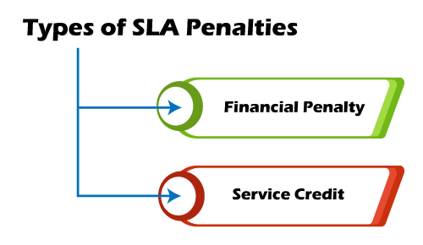
1. Financial penalty
This kind of penalty requires a vendor to pay the customer compensation of damages equal to the one written in the agreement. The amount will depend on the extent of a violation and damage and may not fully reimburse what a customer paid for the eCommerce service or eCommerce support.
- License extension or support:It requires the vendor to extend the license term or offer additional customer support without charge. This could include development and maintenance.
2. Service credit
In this case, a service provider will have to provide a customer with complimentary services for a specific time. To avoid any confusion or misunderstanding between the two parties in SLA violation, such penalties must be clearly articulated in the agreement. Otherwise, they won't be legitimate.
- Service availability:It includes factors such as network uptime, data center resources, and database availability. Penalties should be added as deterrents against service downtime, which could negatively affect the business.
- Service quality:It involves performance guarantee, the number of errors allowed in a product or service, process gaps, and other issues that relate to quality.
These penalties must be specified in the language of the SLA, or they won't be enforceable. In addition, some customers may not think the service credit or license extension penalties are adequate compensation. They may question the value of continuing to receive a vendor's services that cannot meet its quality levels.
Consequently, it may be worth considering a combination of penalties and including an incentive, such as a monetary bonus, for more than satisfactory work.

Revising and Changing an SLA
Since business requirements are subject to change, it's important to revise an SLA regularly. It will help to always keep the agreement in line with the business's service level objectives. The SLA should be revised when changes of the following occur:
- A company's requirements
- Workload volume
- Customer's needs
- Processes and tools
The contract should have a detailed plan for its modification, including change frequency, change procedures, and changelog.
1. SLA Calculation
SLA assessment and calculation determine a level of compliance with the agreement. There are many tools for SLA calculation available on the internet.
2. SLA uptime
Uptime is the amount of time the service is available. Depending on the type of service, a vendor should provide minimum uptime relevant to the average customer's demand. Usually, a high uptime is critical for websites, online services, or web-based providers as their business relies on its accessibility.
3. Incident and SLA violations
This calculation helps determine the extent of an SLA breach and the penalty level foreseen by the contract. The tools usually calculate a downtime period during which service wasn't available, compare it to SLA terms and identify the extent of the violation.
4. SLA credit
If a service provider fails to meet the customer's expectations outlined in the SLA, a service credit or other type of penalty must be given as a form of compensation. A percentage of credit depends directly on the downtime period, which exceeded its norm indicated in a contract.

Service Level Management
Service level management is the process of managing SLAs that helps companies to define, document, monitor, measure, report, and review the performance of the provided services. The professional SLA management services should include:
- Setting realistic conditions that a service provider can ensure.
- Meeting the needs and requirements of the clients.
- Establishing the right metrics for evaluating the performance of the services.
- Ensuring compliance with the terms and conditions agreed with the clients.
- Avoiding any violations ofSLA terms and conditions.
An SLA is a preventive means to establish a transparent relationship between both parties involved and build relationships in the cooperation. Such a document is fundamental to a successful collaboration between a client and a service provider.
ast Updated : 15 Mar, 2021

Service Catalog Management: All You Need to Know
By Simplilearn
Last updated on Mar 7, 202317318


Table of Contents
What is Service Catalog
Purpose and Objectives of Service Catalog Management
Scope of Service Catalog Management
Value to the Business
Types of Service Catalog
View More
Service catalog provides a central source of information on the services delivered by the service provider It is the only part of service portfolio published to customers It supports sale and delivery of IT services catalog is useful in developing solutions from one or more services.
This tutorial explores how the process of service catalog management contributes to SOA practices and more. And by the end of this ‘Service catalog Management’ tutorial, you will be able to:
- Understand the complete overview of the objectives, scope and of the importance of service catalog management as an interface to the service portfolio, as well as of the difference between a business and a technical service catalog.
- Explore the Service catalog management policies, principles, concepts, activities, methods, and techniques in relation to SOA.
- Review the efficient use of service catalog management metrics.

What is Service Catalog
Service Catalog is a tool for service portfolio management decisions. It identifies the linkage between service assets, services, and business outcomes It also identifies the demand for a service and shows how the service provider will fulfill the demand.
Now, we will learn the purpose of the service catalog management process.

Purpose and Objectives of Service Catalog Management
The purpose of the service catalog management process is to provide and maintain a single source of consistent information on all operational services and those being prepared to be run operationally and to ensure that it is widely available to those who are authorized to access it. The objective of the service catalog management process are to:
- Manage the information contained in the service catalog
- Ensure that the service catalog is accurate and reflects the current details, status, interfaces, and dependencies of all services that are being run, or being prepared to run, in the live environment, according to the defined policies
- Ensure that the service catalog is made available to those approved to access it in a manner that supports their effective and efficient use of service catalog information
- Ensure that the service catalog supports the evolving needs of all other service management processes for service catalog information, including all interface and dependency information.

Clear the ITIL 4 Exam in First Attempt
ITIL 4 FoundationEXPLORE PROGRAM


Scope of Service Catalog Management
The scope of the service catalog management process is to provide and maintain accurate information on all services that are being transitioned or have been transitioned to the live environment. The services presented in the service catalog may be listed individually or, more typically, some or all of the services may be presented in the form of service packages. The service catalog management process covers:
- Contribution to the definition of services and service packages
- Development and maintenance of service and service package descriptions appropriate for the service catalog
- Production and maintenance of an accurate service catalog Interfaces, dependencies, and consistency between the service catalog and the overall service portfolio
- Interfaces and dependencies between all services and supporting services within the service catalog and the CMS
- Interfaces and dependencies between all services, and supporting components and configuration items (CIs) within the service catalog and the CMS.
The service catalog management process does not include:
- Detailed attention to the capturing, maintenance and use of service asset and configuration data as performed through the service asset and configuration management process.
- Detailed attention to the capturing, maintenance and fulfillment of service requests as performed through request fulfillment.

Value to the Business
The service catalog provides a central source of information on the IT services delivered by the service provider organization. This ensures that all areas of the business can view an accurate, consistent picture of the IT services, their details and their status. It includes a customer-facing view (or views) of the IT services in use, how they are intended to be used, the business processes they enable, and the levels and quality of service the customer can expect for each service. Through the work of service catalog management, organizations can:
- Ensure a common understanding of IT services and improved relationships between the customer and service provider by utilizing the service catalog as a marketing and communication tool
- Improve service provider focus on customer outcomes by correlating internal service provider activities and service assets to business processes and outcomes
- Improve efficiency and effectiveness of other service management processes by leveraging the information contained in or connected to the service catalog Improve knowledge, alignment and focus on the ‘business value’ of each service throughout the service provider organization and its activities.
Let us know more about the Service catalog in the next section and find what the aspects of the Service catalog are.

Clear the ITIL 4 Exam in First Attempt
ITIL 4 FoundationEXPLORE PROGRAM


Types of Service Catalog
The structure and presentation of the service catalog should support the uses, to which it will be put, taking into consideration the different, sometimes conflicting needs of different audiences. Not every service is of interest to every person or group. Not every piece of information about a service is of interest to every person or group.
When service providers have many customers or serve many businesses, there may be multiple service catalog views projected from the service portfolio. When initially completed, the service catalog may consist of a matrix, table or spreadsheet. Many organizations integrate and maintain their service portfolio and service catalog as part of their CMS.
By defining each service as a CI and, where appropriate, relating these to form a service hierarchy, the organization is able to relate such things as incidents and requests for change to the services affected, thus providing the basis for service monitoring and reporting using an integrated tool (e.g. ‘list or give the number of incidents affecting this particular service’).
It is therefore essential that changes within the service portfolio and its constituent service catalog are subject to the change management process. It is advisable to present more than one view of the information in the service catalog to accommodate the different needs of those who will use it.
In order to ensure that both the customer and IT have a clear understanding of the relationship between the outcome-based, customer-facing services and the business processes they support, it is recommended that a service provider, at the minimum, defines two different views, each one focusing on one type of service:
- a view for customers that shows the customer-facing services,
- a second view for the IT service provider showing all the supporting services.
The data stored in the service catalog regarding relationships and dependencies between items would allow information in one view to be accessed from another when deemed appropriate. Service catalog has two views.
- Business/ Customer Service catalog view and
- Technical Service catalog view.

The Business/Customer Service Catalog View:
This contains details of all the IT services delivered to the customers (customer-facing services), together with relationships to the business units and the business processes that rely on the IT services. This is the customer view of the service catalog. In other words, this is the service catalog for the business to see and use.

The Technical/Supporting Service Catalog View
This contains details of all the supporting IT services, together with relationships to the customer-facing services they underpin and the components, CIs and other supporting services necessary to support the provision of the service to the customers.
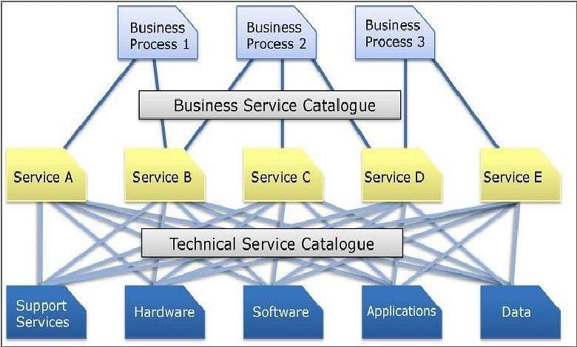
Some organizations only maintain either a Business Service catalog or a Technical Service catalog. The preferred situation adopted by the more mature organizations maintains both aspects within a single Service catalog, which is part of a totally integrated Service Management activity and Service Portfolio.
The Business Service catalog facilitates the development of a much more proactive or even pre-emptive SLM process, allowing it to develop more into the field of Business Service Management.
The Technical Service catalog is extremely beneficial when constructing the relationship between services, SLAs, OLAs and other underpinning agreements and components, as it will identify the technology required to support service and the support group(s) that support the components.
The combination of a Business Service catalog and a Technical Service catalog is invaluable for quickly assessing the impact of incidents and changes in the business.
In the next section, we will understand the key activities within the Service Catalog Management process.

Clear the ITIL 4 Exam in First Attempt
ITIL 4 FoundationEXPLORE PROGRAM


Process Activities
The key activities within the service catalog management process should include:
- Agreeing and documenting a service definition and description for each service with all relevant parties Interfacing with service portfolio management to agree the contents of the service portfolio and service catalog
- Producing and maintaining an accurate service catalog and its contents, in conjunction with the overall service portfolio
- Interfacing with the business and ITSCM on the dependencies of business units and their business processes with the customer-facing IT services contained within the service catalog
- Interfacing with support teams, suppliers and service asset and configuration management on interfaces and dependencies between IT services and the supporting services, components and CIs contained within the service catalog
- Interfacing with business relationship management and SLM to ensure that the information is aligned with the business and business process.

Triggers, Inputs, and Outputs related to Service Catalog Management
The triggers, input, and output related to Service Catalog Management are discussed below:

Triggers
The triggers for the service catalog management process are changes in the business requirements and services, and therefore one of the main triggers is RFCs and the change management process. This will include new services, changes to existing services or services being retired.

Inputs
Some sources of information are relevant to the service catalog management process. These include:
- Business information from the organization’s business and IT strategy, plans and financial plans, and information on their current and future requirements from the service portfolio
- BIA, providing information on the impact, priority, and risk associated with each service or changes to service requirements
- Business requirements: details of any agreed, new or changed business requirements from the service portfolio
- The service portfolio and all related data and documents
- The CMS
- RFCs Feedback from all other processes.

Outputs
The process outputs of the service catalog management process are:
- The documentation and agreement of a ‘definition of the service.’
- Updates to the service portfolio: should contain the current status of all services and requirements for services
- Updates to RFCs
- The service catalog: should contain the details and the current status of every live service provided by the service provider or service being transitioned into the live environment, together with the interfaces and dependencies.
In the next section, we will know what the key information within the service catalog management process is and find different approaches to managing service catalog information.

Information Management
The key information within the service catalog management process is that which is contained within the service catalog. The main input for this information comes from the service portfolio and the business via either the business relationship management or SLM processes. This information needs to be verified for accuracy before being recorded in the service catalog.
The information and the service catalog itself need to be maintained using the change management process. There are many different approaches to managing service catalog information including:
- Intranet solutions built by the service provider organization leveraging technology already in place
- Commercially available solutions designed for service catalog management Solutions that are part of a more comprehensive service management suite.
- The service catalog data may be held in a single repository or multiple repositories.
- Some service providers may maintain the data that supports different views of the service catalog in different locations or toolsets. For example, detailed data for supporting services may be stored in the CMS and presented via the same interface used to access other service asset and configuration data, while data on customer-facing services may be in a browser-based application and presented to customers via the corporate intranet.
When constructing different views of the service catalog, the service provider should consider which services (rows of data) and which data elements or fields (columns of data) should be included in each view. For example, while details of relationships of support services may be important to include in a view intended for staff members of the service provider, these details are typical of no interest to customers and would be excluded from a customer-facing view.
Integration with the service portfolio is critical here, as is the ability to access other closely related functionality, such as customers being able to view their service level agreement monitoring reports or to access a self-help portal for service requests. Some commercially available ‘service catalog’ tools are maturing to offer management of the full-service portfolio, from proposal through to retirement.
Each organization should consider carefully what solution will best serve it's current and future needs. It is important, however, not to confuse the toolset used to present the service catalog with the catalog itself. An organization with a paper catalog and an organization with a robust technical solution both still have a service catalog.
Let us learn the main Critical Success Factors and the two main Key Performance Indicators (KPIs), associated with the Service catalog and its management.

Clear the ITIL 4 Exam in First Attempt
ITIL 4 FoundationEXPLORE PROGRAM


Critical Success Factors and KPIs
The main Critical Success Factors are:
- An accurate Service catalog
- Business users’ awareness of the services being provided
The two main Key Performance Indicators (KPIs) associated with the Service catalog and its management are:
- The number of services recorded and managed as a percentage of those being delivered and transitioned in the live environment
- The number of variances detected between the information contained within the Service catalog and the ‘real-world’ situation
Let us understand the major challenges and the risks associated with the provision of an accurate service catalog in the next section.

Challenges and Risks
Let us look into the challenges and risks involved in Service Catalog Management below:

Challenges
The major challenge facing service catalog management is that of
- maintaining an accurate service catalog as part of a service portfolio
- incorporating all catalog views as part of an overall CMS and SKMS.
One approach may be to develop stand-alone spreadsheets or databases before trying to integrate the service catalog and service portfolio within the CMS or SKMS. In order to achieve this, the culture of the organization needs to accept that the catalog and portfolio are essential sources of information that everyone within the IT organization needs to use and help maintain.
This will often assist in the standardization of the service catalog and the service portfolio and enable an improvement in cost performance through economies of scale.

Risks
The risks associated with the provision of an accurate service catalog are:
- The inaccuracy of the data in the catalog and it not being under rigorous change control
- Poor acceptance of the service catalog and its usage in all operational processes. The more active the catalog is, the more likely it is to be accurate in its content Inaccuracy of information received from the business, IT and the service portfolio, with regard to service information
- Insufficient tools and resources required to maintain the information
- Poor access to accurate change management information and processes
- Poor access to and support of appropriate and up-to-date CMS and SKMS for integration with the service catalog
- Circumvention of the use of the service portfolio and service catalog
- The information is either too detailed to maintain accurately or at too high a level to be of any value. It should be consistent with the level of detail within the CMS and the SKMS.

Production of Service Catalog
The key points of maintaining a service catalog include:
- It should preferably be stored as a set of ‘service’ CIs within a CMS, maintained under Change Management.
- It should be available to anyone within the organization.
- Every new service should be entered into the Service catalog once its initial definition of requirements has been documented and agreed.
- The Service catalog should record the status of every service, through the stages of its defined lifecycle.
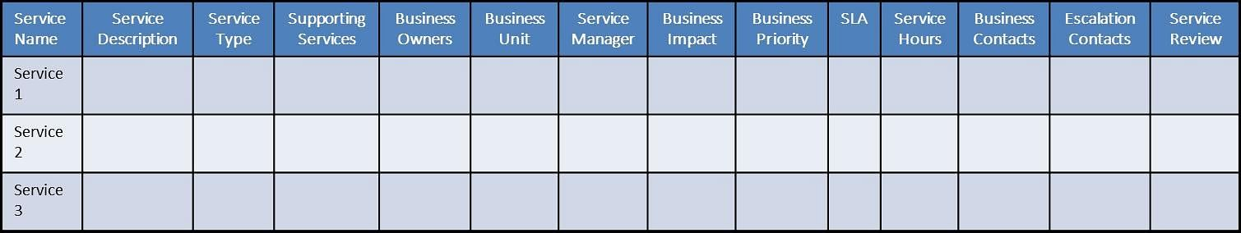
Are you looking forward to becoming an ITIL expert? Check out the ITIL Foundation Certification Course and get certified.

Conclusion
Now that you know all about service catalog management, you might want to strengthen other ITIL concepts too. And if you wish to excel in your ITIL career, Simplilearn’s ITIL V4 Foundation should be your next stop! So what is the wait for? Explore the course right away, and step up your career game now!

